

PRESS RELEASE

Bishop Robert Lebel
Bishop Emeritus of Valleyfield
November 8, 1924 – May 25, 2015

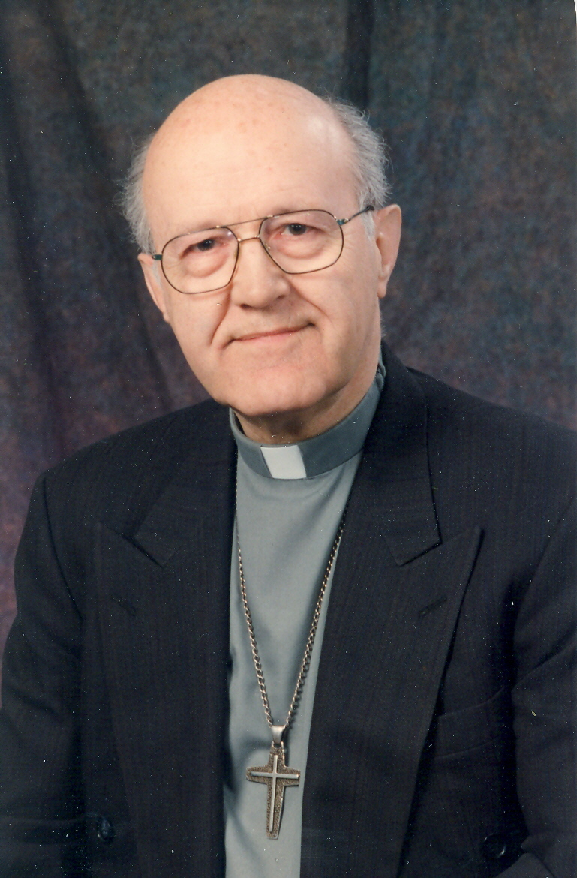
[Salaberry-de-Valleyfield, May 26, 2015] – Bishop Robert Lebel, Bishop Emeritus of the Diocese of Valleyfield, passed away on May 25, 2015. He was 90-years-old.

Ordained to priesthood in 1950 in Trois-Pistoles, in the Archdiocese of Rimouski, he served as an auxiliary bishop in Saint-Jean-Longueuil in 1974, and as the Bishop of Valleyfield from 1976 to 2000.

His body will be exposed in Sainte-Cécile’s Basilica Cathedral in Salaberry-de-Valleyfield on Tuesday June 2, 2015, between 2 PM and 9 PM, and Wednesday, June 3, at 10:30 AM. Bishop Noël Simard will preside his funerals there at 2 PM, after which Bishop Lebel’s body will be buried in Valleyfield’s cemetery, in the lot reserved for the bishops.

The parish of Saint-Clément in Beauharnois will lead a Celebration of the Word at 7:30 PM on the June 2.

Other than Bishop Noël Simard, Bishop Robert Lebel will be mourned by his diocesan families of Rimouski, Saint-Jean-Longueuil, and Valleyfield; his sisters, Cécile Lebel-Rioux, Lucienne Lebel-Lagacé, Sister Annette Lebel, src, Denise Lebel-Morency; his brother Dr. Marcel Lebel; his nephews, nieces, and all the members of the Lebel, Bélanger, Lagacé et Pettigrew families.

To honor his memory, a donation may be made to Fonds Mgr Lebel, 11, rue de l’Église, Salaberry-de-Valleyfield, QC J6T 1J5. With these funds, Bishop Robert Lebel held dear to support youth ministry in the diocese.

—30—

Source: Suzanne Crête-Legault
Media Contact
communications@diocesevalleyfield.org
Phone: 450-373-8122, ext.: 217

