Council on Church and Society
Assembly of Quebec Catholic Bishops
May 1st Message, 2015

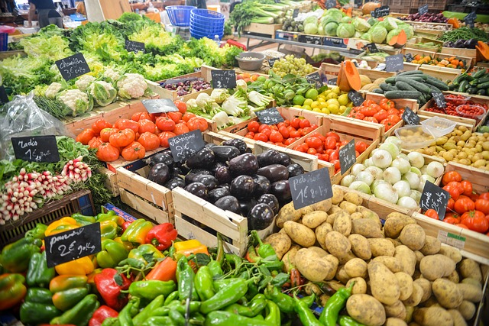
The human person
at the heart
of food sovereignty

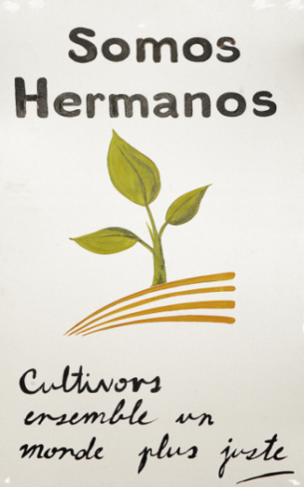
On this May 1, 2015, we wish to honour food workers everywhere. We owe our gratitude to those who plough and seed the ground, those who transform food and ensure its distribution. Their work is essential to our survival, responding to each person’s right to have enough to eat, and they contribute to peoples’ food sovereignty which is threatened by seed control and land-grabbing. They draw extraordinary resources from Mother Earth to feed seven billion men and women. Respect for the human person and for the Earth is at the heart of our food supply.

Like the international peasant movement La Via Campesina, we can define food sovereignty as “the right of peoples to healthy and culturally appropriate food produced through ecologically sound and sustainable methods, and their right to define their own food and agriculture systems.” It requires a delicate balance between the needs of peoples and the capacities of Mother Earth: altering the fragile balance of Mother Earth puts the most vulnerable populations in danger.

We face several challenges in maintaining this balance:
- Respect for workers, throughout the food supply chain, especially seasonal workers;
- Respect for the people, who require healthy and affordable food;
- Respect for the Earth, whose resources are not inexhaustible.

Respect for workers throughout
the food supply chain, especially seasonal workers
“In most cases … immigrants fill a labour need which would otherwise remain unfilled in sectors and territories where the local workforce is insufficient or unwilling to engage in the work in question.” (Compendium of the Social Doctrine of the Church, para. 297)

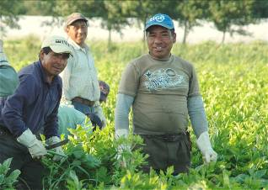
To ensure our food sovereignty, Québec growers must call on migrant workers, more than 8500 of them. These men and women, most of them Latin American, leave their families for periods from six months to a year to help Québec growers at every step of the agricultural production cycle.

Growers value seasonal workers as an affordable, competent, and available workforce. As a society, however, are we prepared to offer them the same rights as our fellow-citizens? Bill 8, recently passed by the Québec government, takes away their right to unionize and thus to claim better working and living conditions. For example, some growers do not have the time to accompany their workers to a hospital or clinic when they are injured or sick; workers who complain are often sent back to their country without possibility of appeal. Sometimes, like the Earth itself, this workforce is mistreated, without any recourse.

In most cases, fortunately, growers respect their seasonal workers, well aware of the indispensable contribution made by this workforce to production and to the growth of their business. Seasonal workers have become an essential link in our food sovereignty.

Respect for the inhabitants of the Earth,
who require healthy and affordable food
“There is no humanity without the cultivation of land; there is no good life without the food that it produces for the men and women of every continent.”
(Pope Francis, January 31, 2015)

For many, eating healthily at an affordable price is a major challenge. Too often, a number of our people do not have the means to feed themselves decently. In March 2014, the food banks of Québec distributed 342 568 food baskets to families consisting of one to six people. Food banks have bare shelves at a time when supermarkets are fuller than ever with food products.
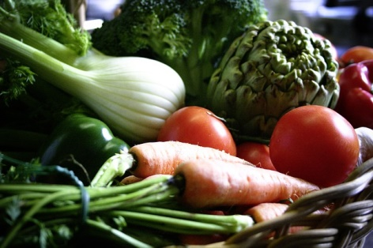
“Our buying habits can have a powerful impact on the lives of our sisters and brothers in the Global South and can send a strong message to politicians and companies that we want a food system that is healthy, sustainable and respects human dignity in all parts of the world.” Consider that 842 million people in the world suffer from hunger. The consumer is the great decision-maker in this food chain. “Buying is voting,” [“Acheter, c’est voter”] says Laure Waridel. By supporting local growers with our purchases, we will influence the entire production process: our growers may be certain of getting their crops to market; more modest transportation needs mean fewer greenhouse gases; the local economy will be in better shape; and we will be in a position to insist that seasonal workers be well treated. And as for products from the global South, when we purchase them, let us make sure that they are fairly traded – they will taste better!

If we were more conscious of the path traced by carrots, broccoli, strawberries, and so forth, on their way to our mouths, we would be more closely tied to the Earth that produces them and to the work of local men and women to ensure our food sovereignty.

Respect for the Earth, whose resources are not inexhaustible
“Behold, I have given you every plant yielding seed which is upon the face of all the earth,
and every tree with seed in its fruit; you shall have them for food”
(Genesis 1:29, Revised Standard Version)

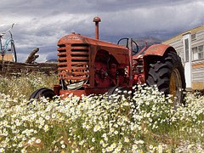
God has given us seeds, not so that certain people might hoard them or transform them at will, but in order to feed all human beings. We are mistreating the Earth as though it were a slave, obliged to produce at any cost. We do not give the Earth time to recover its strength. Our forefathers knew very well that crops had to be rotated and that fields had to be allowed to lie fallow from time to time in order to stay productive. The Earth can feed all its inhabitants if we treat it with respect.

The Development and Peace organization has spoken out repeatedly against multinationals that hoard seeds and crops, to the detriment of small farmers and of the people as a whole. If we opt to grow corn in order to produce methanol, we will have less land to feed our people. By grabbing lands in the South to feed the North, we are throwing off balance the quest of the people who inhabit those lands for food sovereignty and, what is even more troubling, we are causing them to go hungry.

“Soil is at the root of life, it is everyone’s treasure – belonging both to generations now alive, and those of tomorrow. We have a duty to protect it,” wrote Bishop Gérard Drainville in 1985. Many prophets of the modern age have warned us for decades of the need to act. The greed of certain people, mechanisms of disinformation, a lack of consultation of affected populations, and our own lack of vigilance endanger our Earth and our food sovereignty.

Let us keep watch: some practical ideas for staying attentive

Food, like water, has a sacred character. They are gifts of life, necessary for the subsistence and growth of the children of God. Let us refrain from wasting them, desire to share them, and learn to make use of surplus quantities.

In order for there to be a genuine food sovereignty, we must fight against the multinationals’ privatization of land and hoarding of seed. Since the 1980s, small family farmers all over the world, including Canada, have been fighting against plant variety protection laws in order to defend their right to sow, exchange, and sell their own seeds, and thereby to defend the biodiversity of our planet. Let us support their efforts.

Let us have great respect for growers and agricultural workers who harvest the fruits of the Earth for us and ensure our subsistence. Let us support their efforts to secure respect for their right to fair and rewarding working conditions.

A HAPPY MAY DAY to all workers, especially to those who work to feed us and secure our food sovereignty!

Council on Church and Society
Mgr Pierre Morissette, président, Mgr Thomas Dowd, Mgr Denis Grondin, Mgr Noël Simard,
Mgr Pierre Gaudette, M Norman Lévesque, M. Pierre Piché, Mme Élisa Fernandez, sfa et Mme Louise Cormier.
- English translation by Richard Bernier
Publication de:
L’Assemblée des évêques catholiques du Québec
3331, rue Sherbrooke Est—Montréal (Québec) H1W 1C5
Téléphone: 514 274-4323 - Télécopieur: 514 274-4383
Courriel: aecq@eveques.qc.ca—Site Internet: http://www.eveques.qc.ca
Publication de
Secrétariat des évêques catholiques du Québec
3331, rue Sherbrooke Est – Montréal (Québec) H1W 1C5
Téléphone : 514 274-4323 - Télécopieur : 514 274-4383
Courriel : aecq@eveques.qc.ca - Site Internet : http://www.eveques.qc.ca

For further reflection :
- Ryan, William F. and Janet Somerville. Living with Limits, Living Well! Hints for neighbours on an endangered planet. CCCB Publications.
- Development and Peace. One Human Family: Food for All. http://www.devp.org/sites/www.devp.org/files/documents/materials/devpeace_sharelent2014_magazine.pdf
- Somos Hermanos: a program to accompany seasonal workers sponsored by the dioceses of Saint-Jean-Longueuil and Valleyfield. [French-language resource].
https://www.facebook.com/somoshermanos1?fref=ts
- Address of Pope Francis to representatives of the Italian National Confederation of Independent Farmers. January 31, 2015.
http://w2.vatican.va/content/francesco/en/speeches/2015/january/documents/papa-francesco_20150131_coldiretti.html

http://foodsecurecanada.org/who-we-are/what-food-sovereignty
http://banquesalimentaires.org/flextop/upload/pdf/c56b9d6eb57815aba1d18489466ea3fc.pdf
“Sow Much Love: small family farmers feed the world,” Development and Peace backgrounder, Fall 2014. https://www.devp.org/sites/www.devp.org/files/documents/materials/devpeace_fall2014_sowmuchlove_backgrounder.pdf
Waridel, Laure. Acheter, c’est voter: le cas du café. Écosociété, 2005.
Drainville, Gérard. Espoirs et défis de l’agriculture dans le Québec d’aujourd’hui. Assembly of Québec Catholic Bishops, February 1985.

