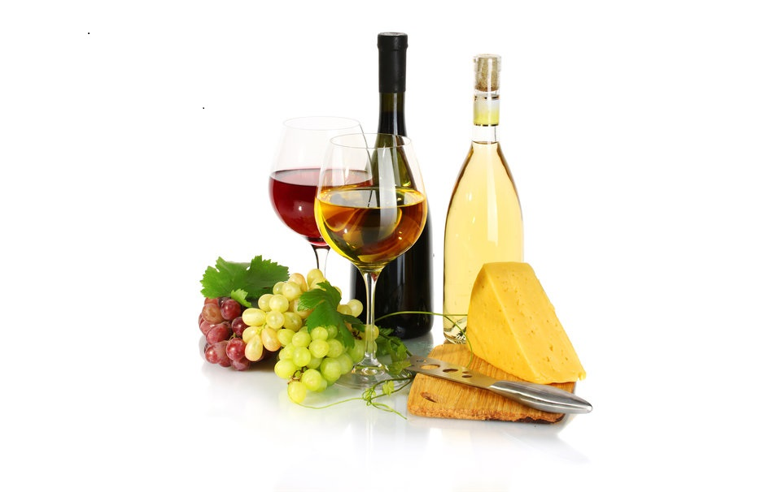

Dates: SEPTEMBER 5 2015, 2PM T0 5PM AND 7PM TO 10PM

Place: PINCOURT OMINI CENTER

375 Boulevard Cardinal Leger, Pincourt J7V 9H6

COST:$15

PROCEEDS GOING TO Oncology of Montreal Childrens hospital and Leukimia

TICKET INFO WILLIAM FLETCHER 514-501-8800

**Fundraising for Cancer: Wine and Cheese Tasting**